WEEK 3 – ADVANCED DATA ANALYSIS AND VISUALIZATION IN LOGISTICS

1 : Introduction :
Logistics data analysis plays an important role in improving delivery efficiency, reducing costs, and identifying operational problems. In this task, exploratory data analysis (EDA) and data visualization techniques are used to examine logistics delivery data and identify meaningful patterns.
The analysis focuses on important logistics variables such as delivery distance, package weight, delivery cost, delivery ratings, vehicle type, delivery delays, region, and weather conditions. Python libraries such as Pandas, Matplotlib, and Seaborn were used to perform the analysis and create visualizations.
The main objective of this analysis is to understand logistics performance, identify possible cost drivers and bottlenecks, and provide useful insights that can support better operational decisions.

2. Dataset and Analytical Objective :
The logistics dataset used for this analysis contains 25,000 delivery records with 15 variables. It includes information related to delivery partners, delivery modes, vehicle types, delivery status, regions, weather conditions, distance, package weight, delivery cost, and customer ratings.
The dataset was previously cleaned and preprocessed before being used for this analysis. Numerical variables such as distance, package weight, and delivery cost were normalized to make them suitable for comparison and analysis.
The main objectives of the analysis are:
To understand the distribution of important logistics variables.
To examine relationships between distance, package weight, delivery cost, and ratings.
To compare delivery performance across different vehicle types.
To identify the proportion of delayed and non-delayed deliveries.
To examine delivery patterns across regions and weather conditions.
To identify factors that may affect logistics cost and operational efficiency.
3. Methodology :
The analysis was performed using Python in Google Colab. The dataset was loaded using the Pandas library and examined to understand its structure, data types, and important variables.
The following steps were used:
1.Data Loading: The cleaned logistics dataset was imported into Python using Pandas.
2.Data Exploration: The shape, column names, data types, and descriptive statistics of the dataset were examined.
3.Descriptive Analysis: Mean, minimum, maximum, and other statistical measures were calculated for selected numerical variables.
4.Correlation Analysis: Correlations between distance, package weight, delivery cost, and delivery rating were examined.
5.Data Visualization: Matplotlib and Seaborn were used to create charts showing distributions, relationships, comparisons, and patterns.
6.Insight Generation: The visualizations and statistical results were interpreted to identify potential cost drivers, delivery patterns, and operational issues.
7.Recommendations: The findings were used to suggest areas where logistics operations could be improved.

Tools and Libraries Used :
- Python – Data analysis
- Pandas – Data handling and analysis
- Matplotlib – Data visualization
- Seaborn – Correlation heatmap
- Google Colab – Python execution environment.

4. Exploratory Data Analysis (EDA) :

4.1 Descriptive Statistics
The table below presents the descriptive statistics of the selected logistics variables.

Statistic | Distance | Package weight | Delivery rating | Delivery cost
Count | 25000 | 25000 | 25000 | 25000
Mean | 0.5001 | 0.5010 | 3.666 | 0.5005
Standard deviation | 0.2944 | 0.2941 | 1.150 | 0.2835
Minimum | 0.0000 | 0.0000 | 1.000 | 0.0000
25%(Q1) | 0.2463 | 0.24659 | 3.000 | 0.2571
50%(Median) | 0.5022 | 0.5010 | 4.000 | 0.5022
75%(Q3) | 0.7540 | 0.7572 | 5.000 | 0.7431
Maximum | 1.0000 | 1.0000 | 5.000 | 1.0000

The descriptive statistics provide an overview of the distribution and variability of the selected logistics variables. The average delivery rating is 3.666, while the normalized distance, package weight, and delivery cost have mean values close to 0.50.

4.2 Central Tendency and Distribution :

Central tendency measures were used to understand the typical values of the selected logistics variables. The mean delivery rating was 3.666 out of 5, indicating an overall moderate-to-positive customer rating.
The normalized distance, package weight, and delivery cost have mean values close to 0.50. Their median values are also close to their respective means, suggesting that the data is generally distributed around the middle of the normalized range.
The distribution of delivery cost was further examined using a histogram to understand how delivery costs are spread across the dataset.

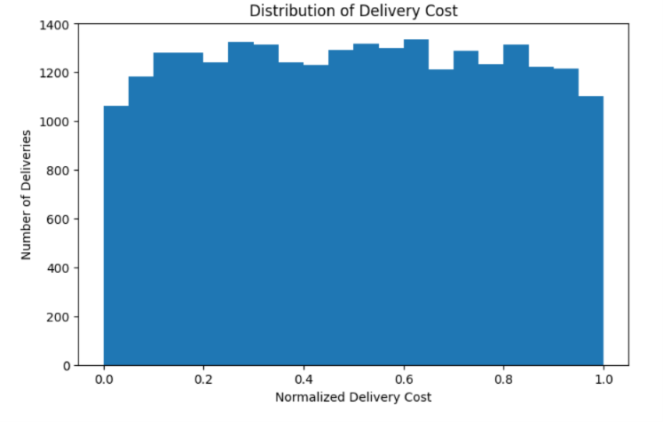
Figure 1: Distribution of Delivery Cost
Interpretation:
The histogram shows that normalized delivery costs are distributed across a broad range of values. This visualization helps identify the overall spread of delivery costs and whether certain cost ranges contain more deliveries than others.

4.3 Correlation Analysis :
Correlation analysis was performed to understand the relationships between distance, package weight, delivery rating, and delivery cost. The correlation coefficient ranges from -1 to +1, where values closer to +1 indicate a strong positive relationship and values closer to -1 indicate a negative relationship.

Variable Pair | Correlation
Distance-Delivery Cost | 0.99
Package weight-Delivery Cost | 0.10
Delivery rating-Delivery Cost | -0.16
Distance-Delivery Rating | -0.13
Package weight-Delivery Rating | 0.00

The results show a very strong positive relationship (0.99) between distance and delivery cost. This suggests that distance is an important factor associated with delivery cost in the dataset. Package weight has only a weak positive relationship with delivery cost (0.10). Delivery rating has weak negative relationships with both delivery cost (-0.16) and distance (-0.13), while package weight and delivery rating show almost no relationship.

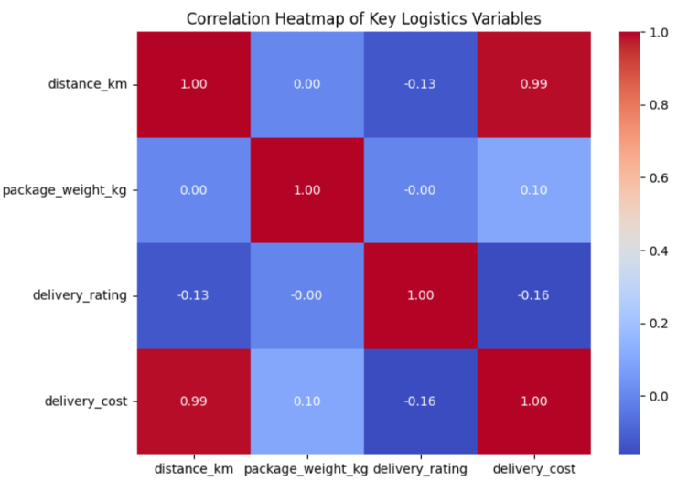

Interpretation:
The heatmap shows that distance and delivery cost have a very strong positive correlation of 0.99. Package weight has a weak positive relationship with delivery cost, while delivery rating has weak negative relationships with distance and delivery cost. Overall, distance appears to be the strongest factor associated with delivery cost among the selected variables.

5.Data Visualizations
5.1 Distance vs Delivery Cost :

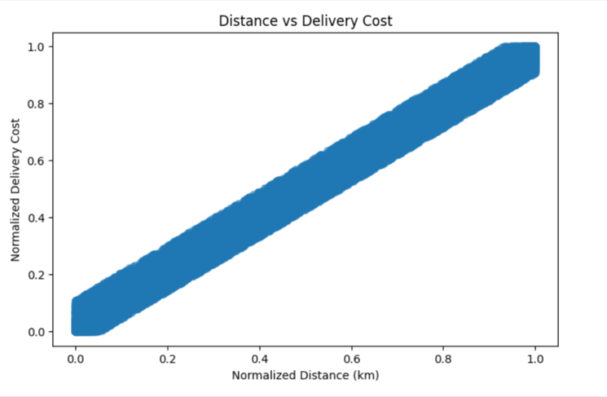

Interpretation :
The scatter plot shows a strong positive relationship between normalized distance and normalized delivery cost. As delivery distance increases, delivery cost also tends to increase. This indicates that distance is an important factor associated with transportation cost.
5.2 Distribution of Delivery Ratings

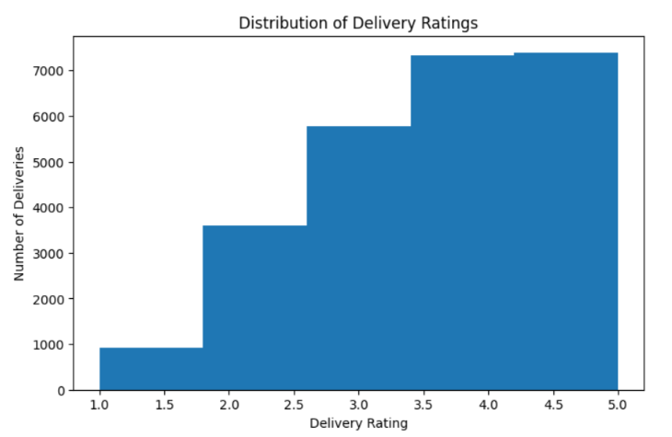

Interpretation:
The histogram shows the distribution of customer delivery ratings from 1 to 5. The average rating is approximately 3.67, indicating an overall moderate-to-positive customer experience. The chart helps identify which rating levels occur most frequently in the dataset.

5.3 Average Delivery Cost by Vehicle Type

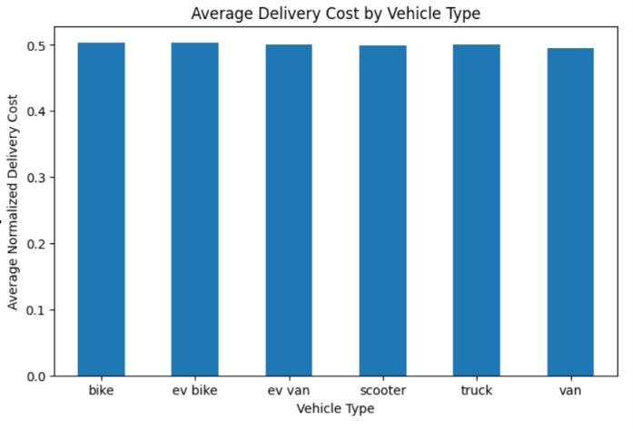

Interpretation:
The bar chart compares the average normalized delivery cost across different vehicle types. The costs are relatively similar across the vehicle categories, suggesting that vehicle type alone does not create a large difference in average delivery cost in this dataset. Other factors, particularly delivery distance, may have a stronger influence on cost.

5.4 Delayed vs Non-Delayed Deliveries

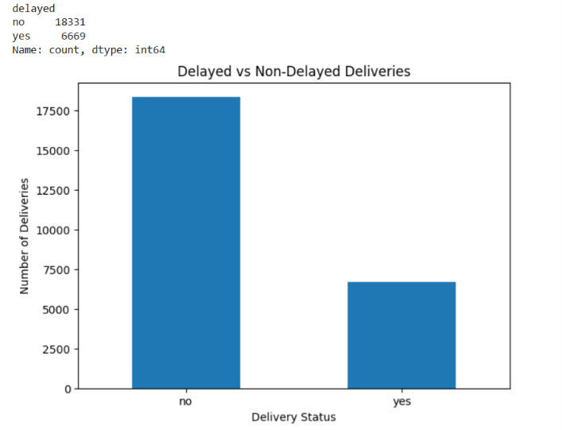

Interpretation:
The chart shows that 18,331 deliveries were not delayed, while 6,669 deliveries were delayed. Therefore, most deliveries were completed without delay, but a considerable number of deliveries experienced delays. This indicates that delivery delays are an area that could be investigated to improve overall logistics performance.

5.5 Delayed vs Non-Delayed Deliveries by Vehicle Type

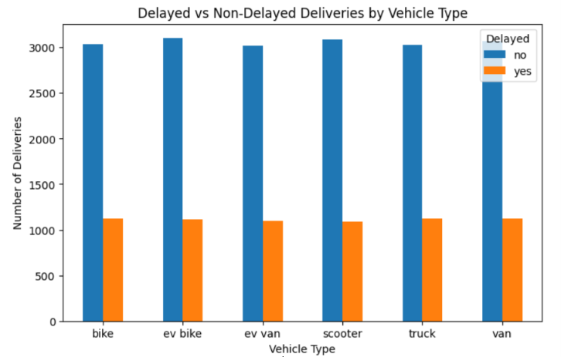

Interpretation:
The chart compares delayed and non-delayed deliveries for each vehicle type. Non-delayed deliveries are higher for every vehicle category. The number of delayed deliveries is relatively similar across the vehicle types, so no single vehicle type clearly dominates the delays. This suggests that factors other than vehicle type may also contribute to delivery delays.

5.6 Number of Deliveries by Region

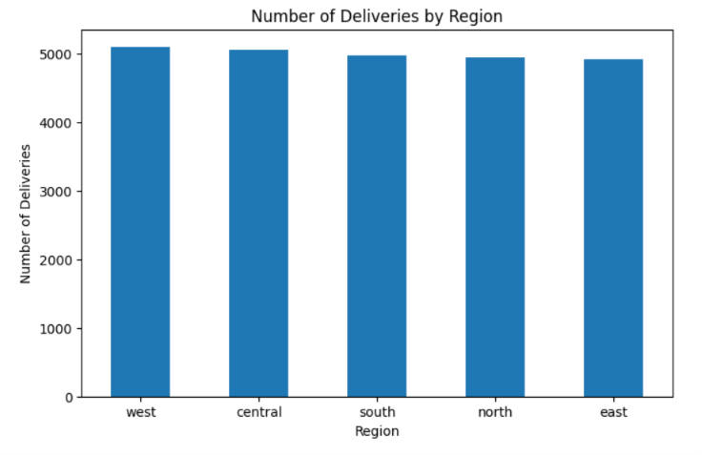

Interpretation:
The bar chart shows the number of deliveries recorded across different regions. Comparing delivery volumes by region helps identify areas with higher or lower shipment activity. This information can support decisions related to resource allocation, vehicle availability, and delivery planning.

5.7 Number of Deliveries by Weather Condition

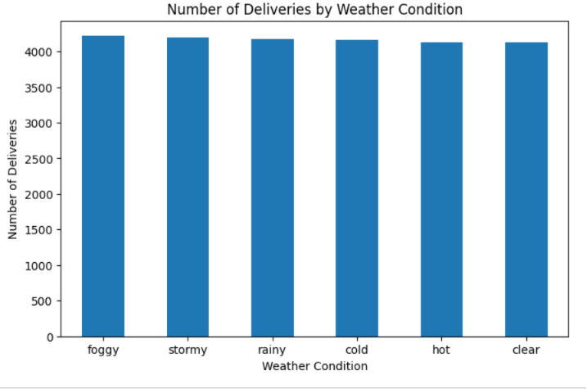

Interpretation:
The bar chart compares the number of deliveries recorded under different weather conditions. Understanding delivery volume under different weather conditions can help logistics teams plan resources and anticipate situations that may affect delivery operations.

6. Analytical Insights
The analysis of the logistics dataset produced several important insights related to delivery cost, customer ratings, vehicle types, and delivery delays.
- Distance is a major cost factor:
The correlation analysis showed a very strong positive relationship (0.99) between normalized distance and normalized delivery cost. This indicates that longer delivery distances are strongly associated with higher delivery costs.

- Delivery delays require attention:
Out of 25,000 deliveries, 6,669 were delayed, while 18,331 were not delayed. Although most deliveries were completed without delays, the number of delayed deliveries is significant and should be investigated.

- Vehicle type does not show a major cost difference:
The average delivery costs across the different vehicle types were relatively similar. Therefore, vehicle type alone does not appear to be the main factor associated with delivery cost.

- Customer ratings are generally moderate-to-positive:
The average delivery rating was 3.666 out of 5. This suggests that the overall customer experience was reasonably positive, while there is still room for improvement.
- Delivery delays are spread across vehicle types:
The comparison of delayed and non-delayed deliveries shows that delays occur across all vehicle categories. No single vehicle type clearly dominates the delayed deliveries.
- Regional and weather patterns can support planning:
Examining delivery volumes by region and weather condition can help logistics teams understand shipment patterns and prepare resources for different operating conditions.
Key Finding
Overall, delivery distance appears to be the strongest factor associated with delivery cost among the selected numerical variables. Reducing unnecessary travel distances through better route planning could therefore help improve cost efficiency.

- Recommendations

Based on the findings from the exploratory analysis and visualizations, the following recommendations can be considered to improve logistics performance:

- Optimize delivery routes:
Since distance has a very strong relationship with delivery cost, route optimization should be used to reduce unnecessary travel and transportation costs.

- Investigate delivery delays:
The delayed deliveries should be analyzed further to identify the main causes, such as distance, weather conditions, delivery mode, or operational issues.

- Improve resource allocation:
Delivery volumes across regions can be monitored to allocate vehicles and delivery resources according to demand.

- Prepare for weather-related conditions:
Weather information can be considered during delivery planning so that potential operational difficulties can be anticipated.

- Monitor customer ratings:
Customer ratings should be regularly monitored to identify areas where delivery service quality can be improved.

- Use data-driven planning:
Logistics decisions should be supported by data analysis and visualization to improve efficiency, reduce costs, and provide better delivery services.

8. Python Code Excerpts
Python was used to perform the data analysis and create the visualizations. The following code excerpts demonstrate the main techniques used during the analysis.

8.1 Loading the Dataset :
import pandas as pd
data = pd.read_csv('/content/Cleaned_Delivery_Logistics.csv')
print(data.head())

8.2 Descriptive Statistics :
columns = [
'distance_km',
'package_weight_kg',
'delivery_rating',
'delivery_cost'
]
print(data[columns].describe())

8.3 Correlation Analysis
correlation = data[
['distance_km',
'package_weight_kg',
'delivery_rating',
'delivery_cost']
].corr()

print(correlation)

8.4 Creating a Visualization
import matplotlib.pyplot as plt
plt.figure(figsize=(8,5))
plt.scatter(
data['distance_km'],
data['delivery_cost'],
alpha=0.5
)
plt.xlabel('Normalized Distance')
plt.ylabel('Normalized Delivery Cost')
plt.title('Distance vs Delivery Cost')
plt.show()

These code excerpts demonstrate the use of Pandas for data analysis and Matplotlib for visualization. Seaborn was also used to create the correlation heatmap.

9. Conclusion
The advanced data analysis and visualization of the logistics dataset provided useful insights into delivery operations and performance. Exploratory data analysis helped understand the characteristics of important logistics variables, while visualizations made patterns and relationships easier to interpret.

The analysis showed a very strong relationship between delivery distance and delivery cost, indicating that distance is an important factor associated with transportation expenses. The analysis also showed that although most deliveries were completed without delays, a significant number of deliveries were delayed and require further investigation.

The comparison of vehicle types showed relatively similar delivery costs and delay patterns across categories. Customer ratings were generally moderate-to-positive, while regional and weather-based delivery patterns can provide useful information for operational planning.

Overall, the analysis demonstrates how Python-based data analysis and visualization can support data-driven logistics decisions, cost management, route planning, and delivery performance improvement.

Key Takeaways
- Distance is strongly associated with delivery cost.
- 6,669 out of 25,000 deliveries were delayed.
- Vehicle type alone does not appear to be the main cost factor.
- The average delivery rating was 3.666/5.
- Data visualization helps identify patterns and support logistics decisions.

